IDEAS PRINCIPALES DEL ARTÍCULO
Design patterns are proven solutions to common problems in software design, but they also apply to other fields like architecture and pedagogy. They emerged in the 1970s and became popular in the 1990s with the GoF book "Design Patterns". The objectives of patterns include reducing time, increasing efficiency, and protecting investment. There are different types of patterns, such as creational, structural, and behavioral. An example of a pattern is waste separation, which solves the problem of material mixing and promotes recycling.
The article presents examples of design patterns in various contexts, including ecological, pedagogical, and software development patterns. It also describes the Centre for Excellence in Teaching and Learning (CETL) project, funded by the Higher Education Funding Council for England, which focuses on creating and evaluating learning objects for university teaching in the UK.
Furthermore, it discusses different formats of design pattern documentation, each with unique characteristics and key elements like context, problem, solution, and consequences. The article provides a comprehensive and detailed overview of using design patterns in developing learning objects, offering concrete examples and practical implementation proposals.

MAPA - CONCEPTUAL
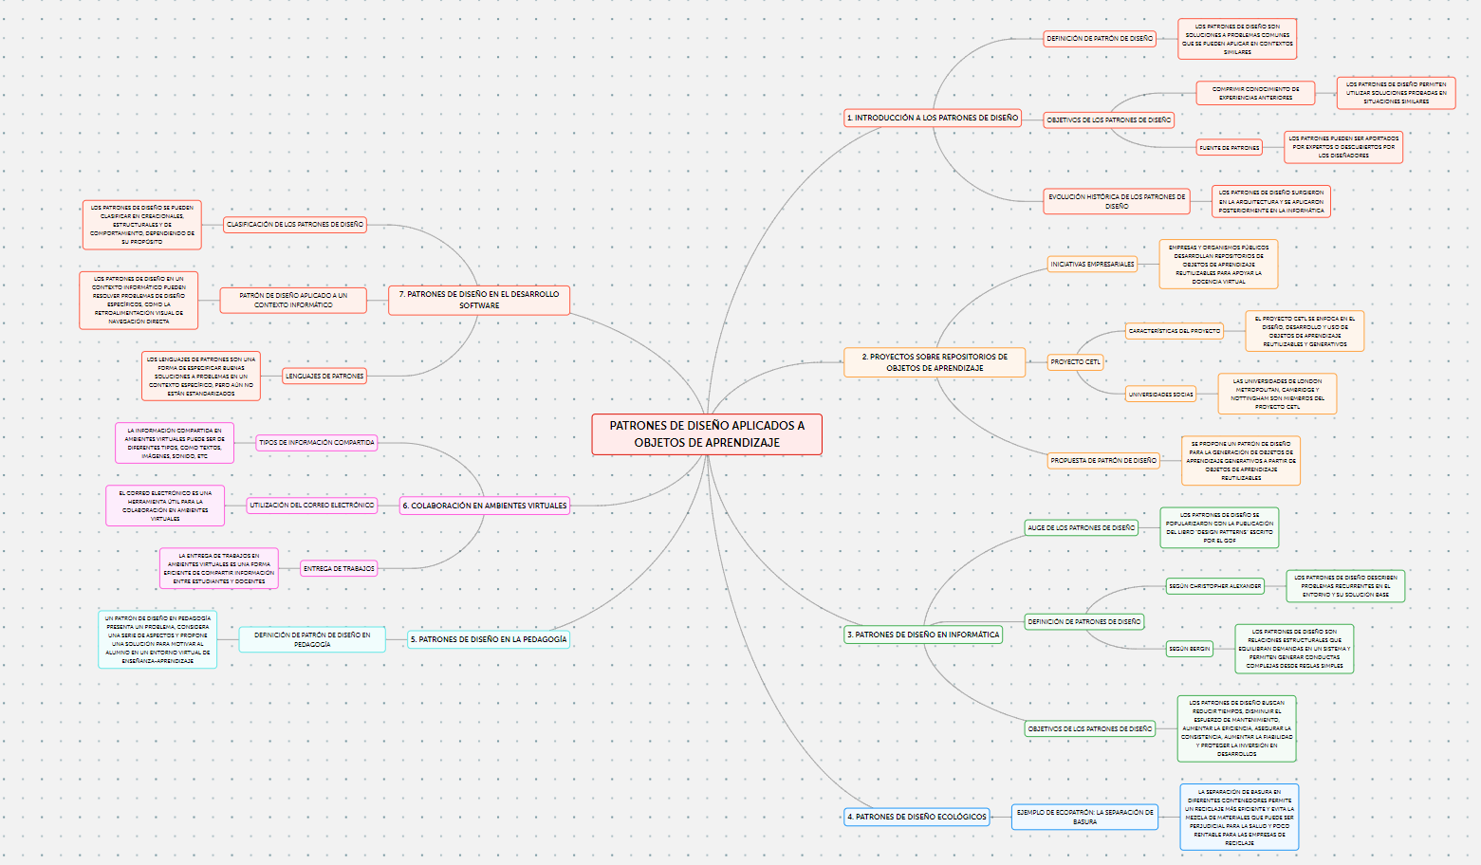

APORTE A SU FORMACIÓN

Studying design patterns is essential for any software developer, as it provides a proven and effective approach to solving common problems in system design. Furthermore, understanding patterns can help improve code quality and efficiency, as well as facilitate communication and collaboration in development teams. It can also provide ideas and solutions applicable in other fields, such as architecture and pedagogy. This text contributes to my education as a systems and computer engineer by providing me with a more comprehensive understanding of design patterns, their historical evolution, and their objectives, thereby equipping me with a new tool to implement not only in programming but also in other areas where patterns can be used to maintain order in projects or activities to be developed.

